**General Information:**

The site will have a neutral-colored tan like background which will be consistent throughout the site. A black header will be at the top of every page. Nav will be centered under the h1 element, both centered in the black header, and in white text. Nav buttons will turn white with black text when hovered over. The index page will feature two divs with a black border containing contact info and qualifications, in black text. The about page will feature content regarding my personality, as well as an image of myself. The portfolio page will feature content regarding my past works. Three images will be featured in a vertical column centered on the page within a div. An h2 will precede each image, with a caption following each image. All pages will also feature a footer in the bottom right of the page in black text.

**Background:**

The site will be a personal portfolio site about its author, Matthew Klapchar. I am a college student working towards a degree in web design. As of now, I have a good understanding of HTML and CSS, as well as PHP basics. Outside of my technical qualifications, I strive to be one of the nicest people you can meet. I have been described as kind, trustworthy, sweet, hardworking, smart, and generous.

**Goals:**

1. The goal is to convey information about myself and my works.
2. The intended audience is any potential employer, or anyone looking to see what I have made.
3. I will build it using HTML and CSS on a text editor.
4. Due to my knowledge on the aforementioned programming languages, the project will take nearly a week to complete.
5. If doing this for a client, I would change the content and styling to the client’s wishes.
6. People would visit my site to learn more about myself and my projects. They will learn about me and how to contact me. In essence, they will learn about one of the nicest people they would meet.
7. The site can be viewed wherever needed, but most likely on a desktop.

**Audience:**

1. The intended audience is potential employers and general users curious about me.
2. They will use the site best on a desktop or laptop.
3. The goal of this site is to learn about Matthew Klapchar and see examples of projects.
4. Desktop or laptop will be best for viewing the site.

**Visual Site Map:**

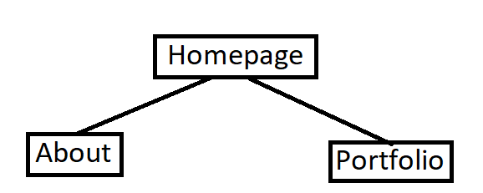

**Content:**

1. The site requires content in the form of screenshots of my work, a description of myself, a photo of myself, and a copyright of the site.
2. Screenshots of my work on the Vicious Cycles, Widget Co., and the resume assignment from WEB-210. A photo of myself will also be needed.

**Features:**

1. Navigation links centered under the h1 in the header that take the user to the different pages of the site.
2. CSS styling for most elements within the site, such as the header and divs.
3. No specific design elements are needed.
4. No JS or PHP will be included.